POWER BI

Remote Desktop Connection

* Username: Administrator
* Password: given in Power BI server

POWER BI Activities

* Through file
* Through database

Activity 1

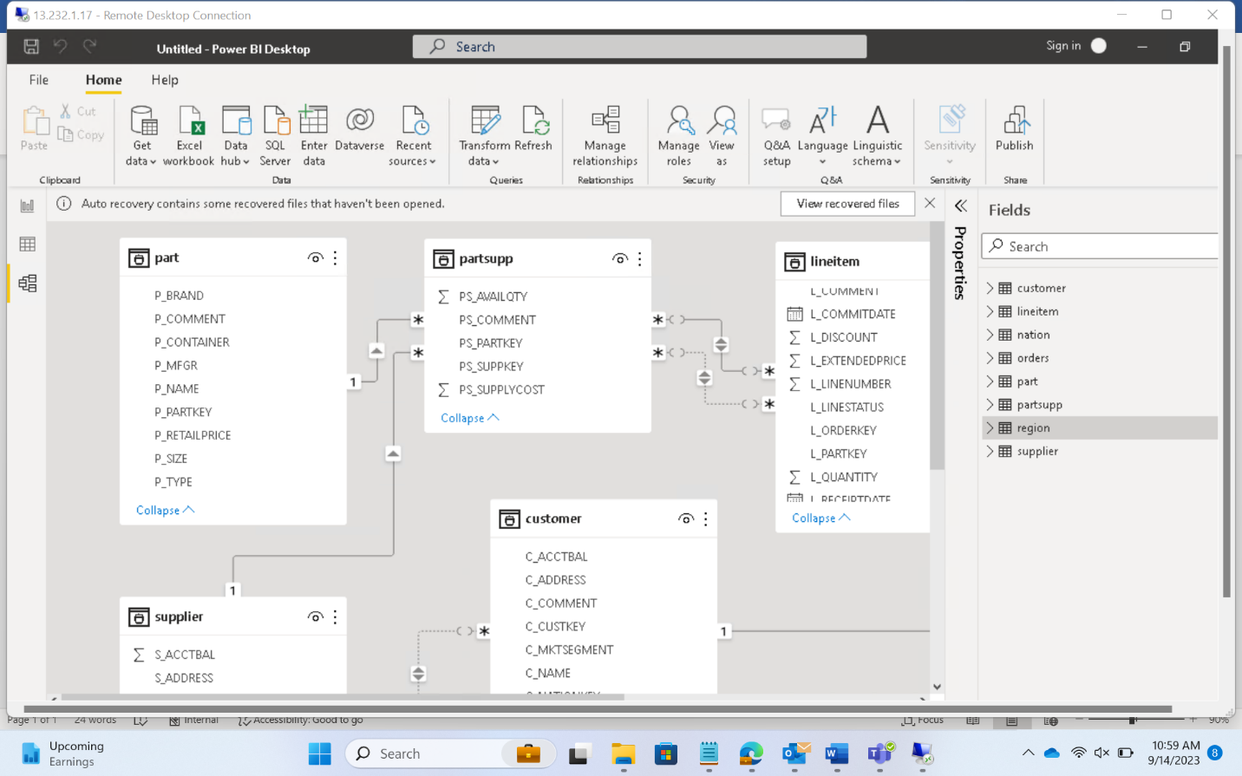

Data Analysis

* Univariant
  + Single variable used
* Bivariant
  + Double variables used
* Multivariant
  + More than 2 variables used
* Count of customers by Nation

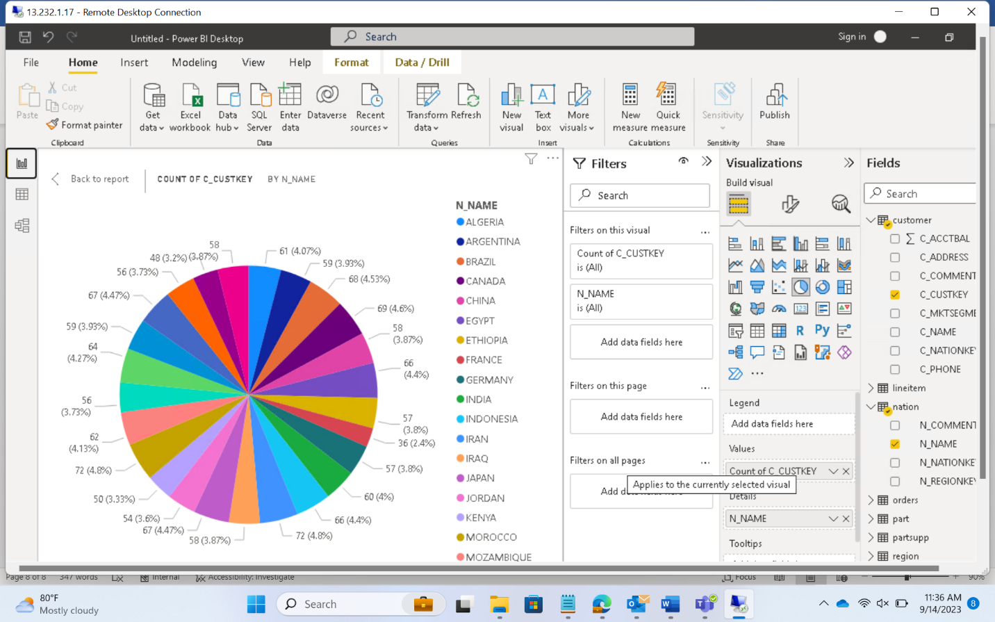

DRILL DOWN

* Date -> year, month, day

DateTable =

ADDCOLUMNS(

CALENDAR(DATE(2023,1,1), DATE(2023,12,31)),

"Year", YEAR([Date]),

"Month Number", MONTH([Date]),

"Month Name", FORMAT([Date], "MMMM"),

"Quarter", QUARTER([Date]),

"Day of Week", WEEKDAY([Date]),

"Day Name", FORMAT([Date], "dddd"),

"Year-Month", FORMAT([Date], "YYYY-MM")

)

Getting data from local db (use SSMS)

###Script

-- Create the database

CREATE DATABASE PetroCorpDB;

GO

-- Use the database

USE PetroCorpDB;

GO

-- Create the DrillingRigs table

CREATE TABLE DrillingRigs (

RigID INT PRIMARY KEY,

RigName NVARCHAR(50) NOT NULL

);

GO

-- Insert sample drilling rigs

INSERT INTO DrillingRigs (RigID, RigName)

VALUES

(1, 'Rig A'),

(2, 'Rig B');

GO

-- Create the DrillingData table

CREATE TABLE DrillingData (

DataID INT PRIMARY KEY,

RigID INT NOT NULL,

[Date] DATE NOT NULL,

DrilledDepth DECIMAL(10, 2) NOT NULL,

DrillingSpeed DECIMAL(10, 2) NOT NULL,

OperatingHours DECIMAL(10, 2) NOT NULL,

DrillBitChanges INT NOT NULL

);

GO

-- Insert sample drilling data

INSERT INTO DrillingData (DataID, RigID, [Date], DrilledDepth, DrillingSpeed, OperatingHours, DrillBitChanges)

VALUES

(1, 1, '2023-09-01', 100, 20, 10, 1),

(2, 1, '2023-09-02', 200, 18, 12, 2),

(3, 1, '2023-09-03', 300, 22, 9, 0),

(4, 1, '2023-09-04', 400, 19, 11, 1),

(5, 1, '2023-09-05', 500, 21, 8, 0),

(6, 2, '2023-09-01', 150, 25, 9, 0),

(7, 2, '2023-09-02', 250, 24, 10, 1),

(8, 2, '2023-09-03', 350, 26, 8, 0),

(9, 2, '2023-09-04', 450, 23, 11, 2),

(10, 2, '2023-09-05', 550, 27, 7, 0);

GO

Real World Scenario

* Anomaly Detection: PetroCorp wants to identify drilling rigs that have experienced an unusually high number of drill bit changes in the last week. They need a report listing the rig names and the number of drill bit changes for each rig over the last seven days.